**Final**

**Practical Exam**

**Instructions:** Choose one of the following projects to complete in class. The files must be submitted via a URL and a zip file to the program that you completed.

**Car going around and around** (5 points)

Note the car track in q4car.html. The start button simply starts the movement of the car around the canvas. Upon clicking the Start button, the caption changes to “Stop” and when clicking the stop button, the car stops and the caption changes back to “Start.” See q4car.mp4 for a 10 second video of the desired behavior.

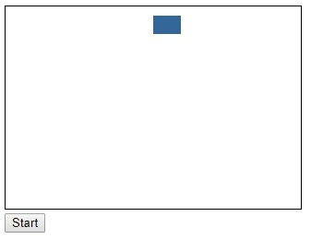

**Random Grid** (5 points)

q1RandomGrid.html displays a 10 by 10 grid with random numbers. Your job is to add code for the three buttons. When clicking on a button, all the numbers equal to the text box to its left you should get the corresponding background color. You must do this by working with the existing grid. You cannot redraw the grid. Instead, the background color of individual divs must change on the click.

